# ZOMATO RESTAURANTS ANALYSIS.

**Objective Questions:**

1. What is the total no. of tables present in the data?

Ans: **2**.

2. What is the total no. of attributes present in the data?

Ans: **20.**

3. How many categorical columns are there in the data? [Search about categorical and continuous data, and try to answer this question]

Ans: **10.**

4. The data consists of some inconsistent and missing values so ensure that the data used for further analysis is cleaned.

Ans: **Removed Missing values as well As those columns which were not required for the analysis. Like Latitude and Longitude and LocalityVerbose.**

5. Using the LookUp functions, fill up the countries in the original data using the country code.

Ans: =**IFNA(VLOOKUP($C2,'country description'!$A$1:$B$16,MATCH('RawData'!D$1,'country description'!$A$1:$B$1,0),0),"Not Available")**

6. Create a table to represent the number of restaurants opened in each country.

Ans:

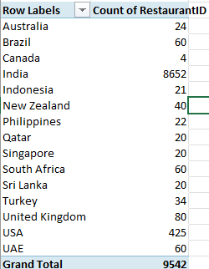

7. Also, the management wants to look at the number of restaurants opened each year, so provide them with something here.

Ans:

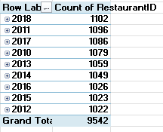

8. What is the total number of restaurants in India in the price range of 4?

Ans: **388.**

9. What is the average number of voters for the restaurants in each country according to the data?

Ans:

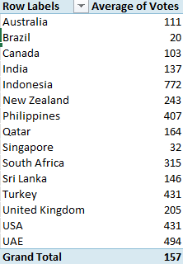

10. Calculate the average rating for all the restaurants that have price_range < 4 and provide online delivery. Use only the “IF” function, Logical Operators, and Aggregation functions to solve this problem. [Note: Don’t use Conditional aggregation in this question.]

Ans: 3.27381151

11. Using Conditional formatting highlight the rows of restaurants that are located in the countries or cities that you’ve suggested to the management for opening new restaurants.

Ans: Considering the rating (Less Than 4) and lowest number Of restaurants (count of less than 10 well-rated restaurants) from each country.

* At first I identified all the countries that are needed to be considered for newer restaurants by following the above criteria.
* Then I have done conditional formatting using the below mentioned formula to format the cells containing the suggested countries.

=OR(D2="Qatar", D2="Sri Lanka", D2="Indonesia", D2="New Zealand", $D2="Canada", $D2="Philippines")

12. Create a new customised price column that consists of the abbreviation/symbol of the currency along with the Average_cost_for_two value. [Use string operations to do this task]

Ans: = Used VlookUp with the Country description table to change all the Currencies to INR.

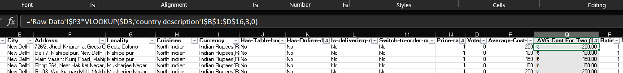 'Raw Data'!$P3*VLOOKUP($D3,'country description'!$B$1:$D$16,3,0)

13. How can you create an array formula in Excel or Google Sheets to count the number of restaurants listed that do not offer online delivery, are in the lowest price range, and have an average cost for two people less than or equal to 250 Indian Rupees?

Ans: 1691

{=SUMPRODUCT((K2:K9543="No")*(N2:N9543=1)*(R2:R9543<=250))}

### **Subjective Question:**

1. Suggest a few countries where the team can open newer restaurants with lesser competition. Which visualisation/technique will you use here to justify the suggestions?

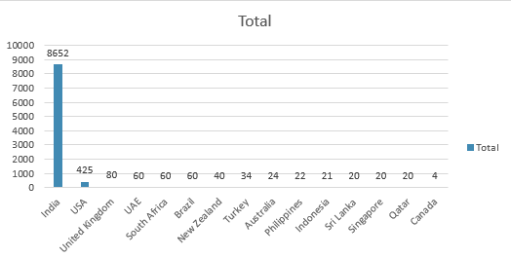**VISUALIZATION:**

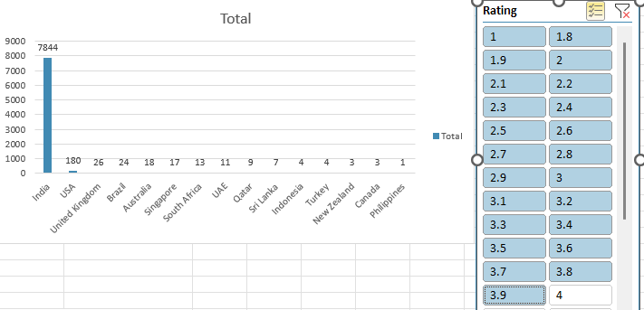

**EXPLANATION:**

* The First chart Represents the total number of restaurants in each country, we will use it for comparing before and after sorting data. I sorted the countries based on ratings of less than 4.
* In second chart I found that very few restaurants in some countries have a good rating of 4 or more.
* In terms of good-rated restaurants Australia has 75% of their total count doing good and we can focus on other countries that are having very low rated restaurants as well as lesser count.
* Mainly we can focus on Qatar, SriLanka, Indonesia, Turkey, New Zealand, Canada and the Philippines.
* Team should focus in opening newer restaurants in above suggested countries as there are less number of restaurants so there will be very less competition and also ratings are also not good.
* Opening newer restaurants and providing good cuisines will definitely attract customers and good rating.

2. Come up with the names of States and cities in the suggested countries suitable for opening restaurants.

**VISUALISATION and SUGGESTIONS:**

**Canada:** Chatham-kent, Consort, Yorkton

**Indonesia:** Bogor, Jakarta, Tangerang

**New Zealand:** Auckland, Wellington City

**Philippines:** Santa Rosa

**Qatar:** Doha

**Sri Lanka:** Colombo

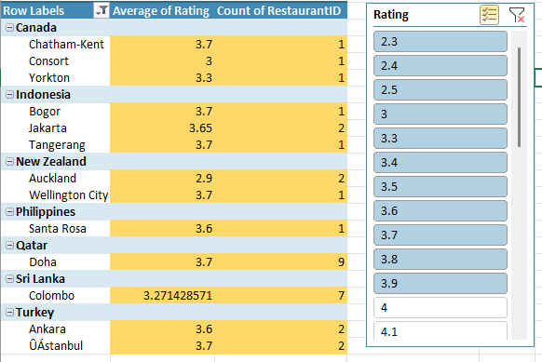**Turkey:** Ankara, ÛÁstanbul

**EXPLANATION:**

* **Considering average Rating 4 as A minimum criteria for opening restaurants.**
* **The mentioned cities are very suitable suggestions for opening newer restaurants.**
* **As there are fewer and very low-rated restaurants, there will be fewer competitors.**
* **By giving**
* **Opening a range of restaurants, the team can focus on getting good rating and gathering more customers.**

3. According to the countries you suggested, what is the current quality regarding ratings for restaurants that are open there?

Ans: **VISUALISATION:**

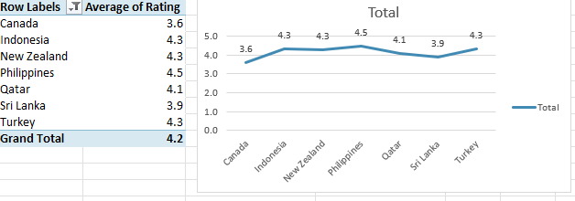

**EXPLANATION:**

* **Here I have suggested Canada, Indonesia, Philippines, Qatar, Srilanka, Turkey and Singapore to open new restaurants.**
* **The above Chart and Table Shows the Average Rating Of the Restaurants that are already there, so that we can determine that the country has a good demographic region to open new restaurants.**
* **Customers will Love it if there will be more other options.**

4.Also, what is the current expenditure on food in the suggested countries, so we can keep our financial expenditure in control?

**VISUALISATION:**

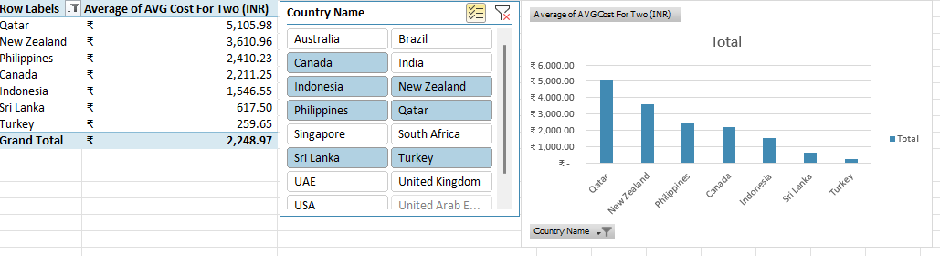

**EXPLANATION:**

* **Here, taking the Avg_cost_for_two as reference, we will look into the food expenditure in each country we have suggested.**
* **This will provide us the insight into how much an average of Two person is spending on food.**
* **It will help us to focus on those countries that are giving less numbers by keeping aside the performing countries.**

5. Come up with the names of restaurants from the recommended states that are our biggest competitors and also those that are rated in the lower brackets, i.e. 1-2 or 2-3.

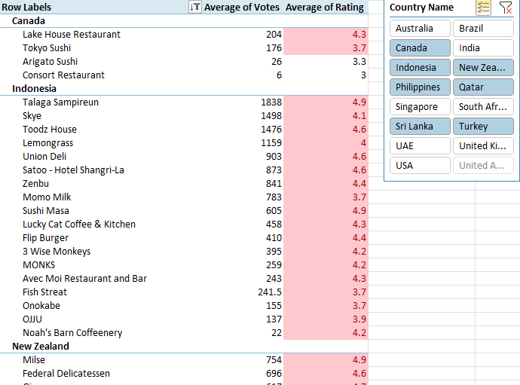 **VISUALISATION**:

**EXPLANATION:**

* **The Above Table shows the suggested countries having the restaurants that are rated in lower brackets i.e., 1-2,2-3**
* **The Highlighted Cells Represents the rating Of More than 3.5.**
* **Considering those restaurants that have rating more than 3.5 are our biggest competitors.**
* **Team can think of opening newer restaurants so that people can get options with the restaurants.**
* **In the pivot table we can see that there are most number of restaurants with rating more than 4. They will be the biggest competitors as they are having the best quality in cuisines and services.**

6. Which cuisines should we focus on in the newer restaurants to get better feedback? Does the choice of cuisines affect the restaurant ratings?

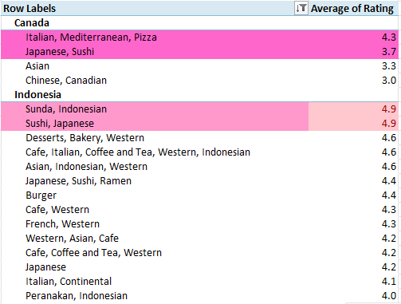VISUALISATION:

EXPLANATION:

* The above pivot table categorises cuisines as per rating in each country.
* Here I considered a rating of 3.5 or more as a good cuisines that the team can introduce in the newer restaurants.
* Taking these cuisines on the menu will be a good choice.
* All the selected cuisines are from the same suggested countries that people like the most in the respective suggested countries.

7. According to our current data, should we go for online delivery and table booking? Does that affect the customer’s ratings?

VISUALISATION:

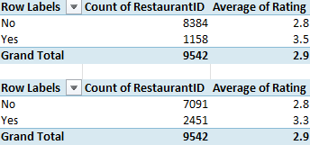

EXPLANATION:

* **Here We Can See in the above table that the restaurants offering table booking have a greater average rating than those not providing.**
* **The same is happening in case of online delivery. Average Rating is higher in comparison to those who have no online delivery.**
* **From The above Table we can say that Online delivery and table booking affects the customers rating.**
* **Thus, suggesting to provide Online delivery and Table booking to increase the Ratings of customers.**

8. Should the team keep the rate of cuisines higher? Will that affect the feedback? According to our data are the rates of cuisines and ratings, correlated?

EXPLANATION:

* **We examined the correlation between restaurant pricing and customer ratings and found that the correlation is 0.34 which means restaurant pricing and customer ratings are loosely correlated.**

9. What is the distribution of the number of restaurants of different price ranges in all the countries?

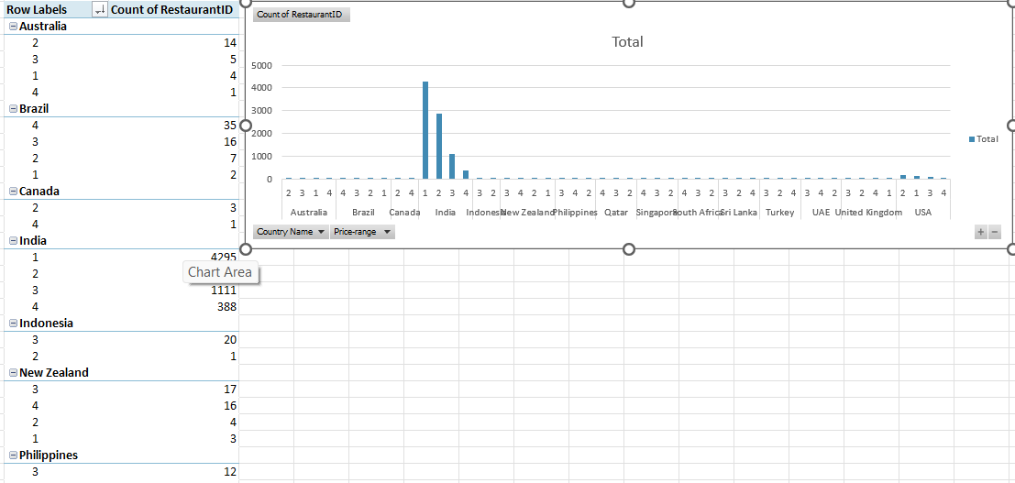 VISUALISATION:

EXPLANATION:

* Here In the above Chart we can see the most price range variation lies in INDIA.

10.Explain your approach in brief for suggesting countries/cities to open new restaurants, if the objective and subjective questions would not have not been given to assist you. [you have to give bullet pointers in order to answer this question]

EXPLANATION

If There won’t be any objective and subjective Given then:

* Firstly, I would have been checked where there is the most number of voters. This will provide me with the idea of population who are using Zomato restaurants.
* Then the countries with lowest voters. This will make us understand where to focus while opening the newer restaurants.
* After getting the population and voting data, next task is to identify the type of cuisines that people are liking the most. It will be based on the Votes and Rating
* After that we also have to identify the price range at which most number of customers are having their cuisines..
* The are which have lesser number of votes and higher price range will be our focus.
* There we should reduce the pricing and provide with the most popular cuisines. This will gather the attention of customers towards less visited restaurants.
* While opening the newer restaurants we should keep in mind that the cusine selection and pricing should be affordable to two. Here we are considering tha price based on an average of two persons.
* We should also keep in mind the availability of services like table booking and online delivery. We can see that the restaurants with both facilities are getting the most liked and votes.